SCOTTISH GUILD OF SERVERS
Requiem Mass
for
Fr Donald Strachan
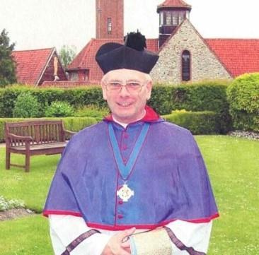

Saturday 20th November 2021
At
St Margaret’s Church
353-355Kilmarnock Road
Newlands, Glasgow
G43 2DS

Requiem Mass at 12pm
Join us to celebrate the life of Fr Donald Strachan and give thanks for his contribution to the Scottish Guild of Servers

This will be followed by refreshments in the church hall

All members of the Scottish Guild of Servers and all other Servers are invited to attend.

Servers are asked to wear Cassocks and Cottas or Surplices; or Albs.

Face Coverings will be a requirement (unless exempt)

