SCOTTISH GUILD OF SERVERS
93rd Festival Eucharist & AGM

Christ Church, Falkirk
Kerse Lane,
Falkirk
FK1 1RX

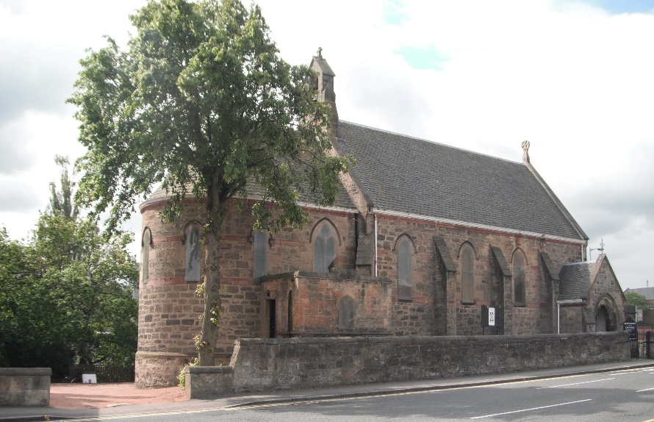

Saturday 3rd September 2022

High Mass at 1pm
Celebrant: Revd Canon Gordon Fyfe
Warden of the Scottish Guild of Servers

Preacher: Bishop John Armes
Bishop of Edinburgh

This will be followed by refreshments and the A.G.M
All members of the Scottish Guild of Servers, all other Servers, their friends and relations are invited to attend.

For those arriving early there will be Rosary at 12 noon

Servers are asked to wear Cassocks and Cottas or Surplices; or Albs
Clergy are asked to wear Cassocks, Cottas or Surplices and White Stoles.

