SCOTTISH GUILD OF SERVERS
94th Festival Eucharist & AGM

St John the Baptist
Scottish Episcopal Church
Princes Street, Perth
PH2 8LJ
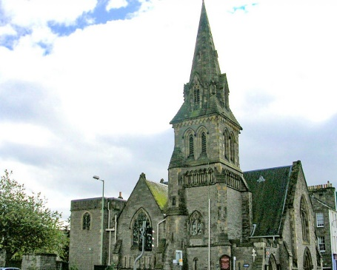

Saturday 2nd September 2023

High Mass at 1pm
Celebrant: Revd Canon Gordon Fyfe
Warden of the Scottish Guild of Servers

Preacher: Bishop Ian Paton
Bishop of St Andrews, Dunkeld & Dunblane

This will be followed by refreshments and the A.G.M
All members of the Scottish Guild of Servers, all other Servers, their friends and relations are invited to attend.

For those arriving early there will be Rosary at 12 noon

Servers are asked to wear Cassocks and Cottas or Surplices; or Albs
Clergy are asked to wear Cassocks, Cottas or Surplices and White Stoles.

There are several council pay & display car parks located near the venue- parking charges will apply

