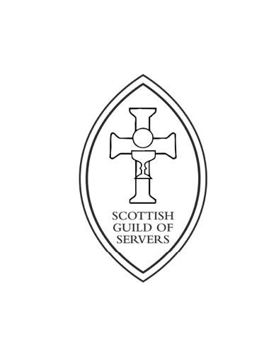
Scottish Guild of Servers

Annual Newsletter – July 2023

Welcome to our New Annual Newsletter!
2022/23 has been a busy year. Since our last Festival and AGM in September 22, held in Christ Church, Falkirk there have been many developments and events throughout the year.
The Council met twice this year, once in Glasgow and then in Edinburgh. The Fraternity Guardians have also met regularly, and they will be sharing an update with members at our next AGM.
The Council approved an updated SGS Manual, this, along with new prayer cards and lapel badges, will be on sale at our sales stall at the Festival and AGM.
Following feedback from our members we thought this newsletter would be helpful in relation to our next Festival and AGM and it is also an opportunity to share with you some of the events that have taken place throughout the year.
I would love to have feedback on this newsletter and hear any ideas you might have that I can share with the Council.
Please get in touch using secretary-general@scottishguildofservers.org or send us a message through our Facebook page.
I look forward to seeing many of you at our 94th Annual Festival in September.
Yours Fraternally,
Vicki
Vicki Paterson- Secretary General

94th Annual Festival and AGM 2023
Plans are well underway for our 94th Annual Festival and AGM. This year we will be hosted by St John the Baptist, Perth on Saturday 2nd September 2023 starting at 1pm. Follow this link for more details: Notice of SGS 94th Festival and AGM 2023 | Scottish Guild of Servers
St John the Baptist is located at:
Princes Street, Perth, PH2 8LJ
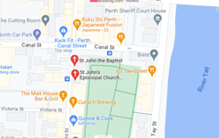
Directions by Car
Sat Nav – use the postcode PH2 8LJ
The map above shows the church location at the junction of Princes Street and Canal Street. Princes Street is one way only, going north, and Canal Street is one way only, going west.
There is plenty of car parking nearby: street parking in and around Princes Street, a car park immediately next to the church on Canal Street, a multi-storey car park just a couple of hundred metres to the west along Canal Street, or a long-stay car park at the north east corner of the South Inch parkland. All parking is by pay and display tickets. The South Inch car park is only 5 minutes’ walk to the church along Princes Street.

Directions By Train
Perth station is served by a regular service by Scotrail . The church is a pleasant 10-minute walk along the north side of the South Inch parkland, and up Princes Street. On leaving the station forecourt, turn right, go under the railway bridge and carry onto to the crossroads with traffic lights, turn left into Princes Street. Alternatively, it is a 3-minute taxi ride to the church, from the station taxi rank.
The Festival and AGM is a wonderful opportunity for members to meet in faith and fellowship. This year Bishop Ian Paton will be preaching.
The SGS Council Needs You!
At the AGM this year we will be electing a new Secretary General, as Sister Vicki Paterson will be standing down from the role. There is also the opportunity for two of our members to join the council. If you would like more information about being a council member and what this entails, please email Sister Vicki Paterson at:
secretary-general@scottishguildofservers.org

Annual Retreat- 1st April 23
On the 1^{st of} April we held our first in person Retreat Day at St Luke the Evangelist, Glenrothes.
Rev Sarah Shaw and Br Ross Stirling led a day of reflection and prayer.
It was a wonderful way to prepare for Holy Week and we hope to repeat the experience next year.
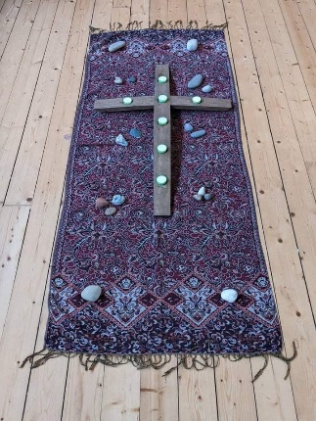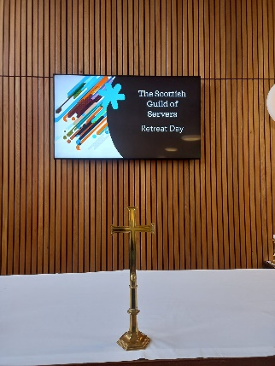
Provincial Training Day – Inverness Catherdral
On Saturday 13th May many of our members took part in a SGS Training Event. Participants had the opportunity to learn more about Altar Serving, Processions, Using the Thurible and preparing for the Eucharist. It was a wonderful opportunity to meet some of our members from Inverness, Buckie and Wick.
Thanks to Sister Mary Dormer- Guardian, for her support in organising this event.
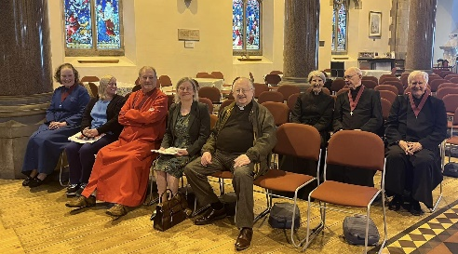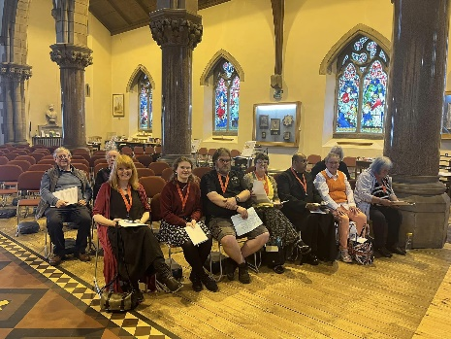
Long Service Awards
Over this last year we have awarded two members of the Scottish Guild of Servers, Long Service Awards.
Br Davy Morrison, from St Andrew’s was awarded his at the AGM in September 22 and Br Jimmy Callaghan, from Inverness was awarded his medal in June 23. Congratulations to you both.
