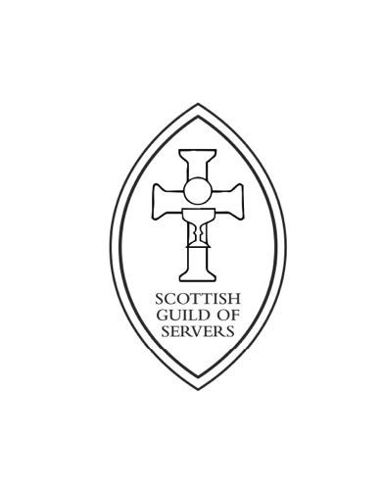
SCOTTISH GUILD OF SERVERS
95th Festival Eucharist & AGM

All Saints
Scottish Episcopal Church North Castle Street St. Andrews KY16 9BG

Saturday 14th September 2024

High Mass at 1pm
Celebrant: Revd Canon Gordon Fyfe
Warden of the Scottish Guild of Servers
Deacon of the Eucharist Rev Canon Dr Alasdair Coles
Deacon of the Word Rev Canon Sarah Shaw
Preacher: Rev Canon Dr. Alasdair Coles

This will be followed by refreshments and the A.G.M
All members of the Scottish Guild of Servers, all other Servers, their friends and relations are invited to attend.

For those arriving early there will be Rosary at 12 noon

Servers are asked to wear Cassocks and Cottas or Surplices; or Albs
Clergy are asked to wear Cassocks, Cottas or Surplices and White Stoles.

There is council pay & display on street car parking located near the venue
parking charges will apply
Parking is available at the Murray Place Car Park 129 North St KY16 9AG[currently advertised as free]

